**Nom : Essence : Cabale :**

**Attitude : Nature : Tradition :**

PM

**PVT PVC PVBG PVBD PVJG PVJD**

**Attributs**

**Magie**

Puissance

Dextérité

Vigueur

**Mental**

Perception

Mémoire

Logique

**Social**

Charisme

Manipulation

Apparence

**Physique**

Force

Dextérité

Vigueur

**Capacités**

**Talents**

Bagarre

Conscience

Esquive

Expression

Intimidation

Intuition

Sports

Subterfuge

Vigilance

Orientation

Parade

**Connaissances**

Cosmologie

Culture

Droit

Enigmes

Investigation

Linguistique

Médecine

Occulte

Sciences

Herboriste

Alphabétisation

**Compétences**

Armes à feu

Commandement

Equitation

Cocher

Etiquette

Furtivité

Méditation

Mêlée

Arme de jet

Archerie

Forgeron

Tailleur

Alchimiste

Enchanteur

Batelier

**Magie/Sorts**

|  |  |  |  |
| --- | --- | --- | --- |
|  |  |  |  |
|  |  |  |  |
|  |  |  |  |
|  |  |  |  |
|  |  |  |  |
|  |  |  |  |

**Historique**

|  |  |
| --- | --- |
|  |  |
|  |  |
|  |  |
|  |  |
|  |  |
|  |  |
|  |  |
|  |  |

**Atout/Handicap**

|  |  |  |  |  |  |  |  |
| --- | --- | --- | --- | --- | --- | --- | --- |
| **Atout** | | | | **Handicap** | | | |
|  |  |  |  |  |  |  |  |
|  |  |  |  |  |  |  |  |
|  |  |  |  |  |  |  |  |
|  |  |  |  |  |  |  |  |
|  |  |  |  |  |  |  |  |
|  |  |  |  |  |  |  |  |
|  |  |  |  |  |  |  |  |
|  |  |  |  |  |  |  |  |

**Background**

**Equipements**

**Armures**

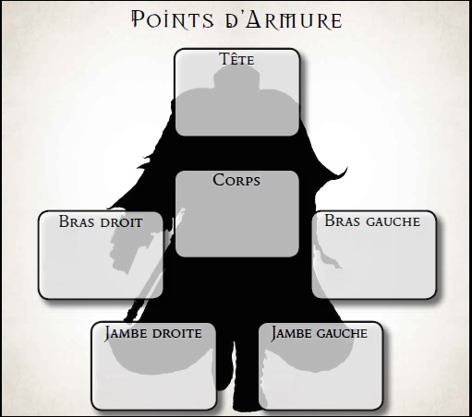

|  |  |  |  |  |  |  |
| --- | --- | --- | --- | --- | --- | --- |
|  | **Réduction(%)** | | **Poids** | **Solidité** | | **Matière** |
| **P** | **M** | **P** | **M** |
| **Tête** |  |  |  |  |  |  |
| **Corps** |  |  |  |  |  |  |
| **Bras** |  |  |  |  |  |  |
| **Jambes** |  |  |  |  |  |  |

**Armes**

|  |  |  |  |  |
| --- | --- | --- | --- | --- |
| **Nom** | **Dégâts** | **Poids** | **Solidité** | **Matière** |
|  |  |  |  |  |
|  |  |  |  |  |
|  |  |  |  |  |
|  |  |  |  |  |

**Anneaux/Amulette/Boucles**

|  |  |  |
| --- | --- | --- |
| **Nom** | **Effet** |  |
|  |  |  |
|  |  |  |
|  |  |  |
|  |  |  |
|  |  |  |
|  |  |  |
|  |  |  |

**Potions**

|  |  |  |
| --- | --- | --- |
| **Nom** | **Effet** | **Nb** |
|  |  |  |
|  |  |  |
|  |  |  |
|  |  |  |
|  |  |  |
|  |  |  |
|  |  |  |

**Autres**

|  |  |  |  |
| --- | --- | --- | --- |
| **Nom** | **Effet/Note/Nb** | **Nom** | **Effet/Note/Nb** |
|  |  |  |  |
|  |  |  |  |
|  |  |  |  |
|  |  |  |  |
|  |  |  |  |
|  |  |  |  |
|  |  |  |  |

|  |  |  |  |
| --- | --- | --- | --- |
|  |  |  |  |
|  |  |  |  |
|  |  |  |  |
|  |  |  |  |
|  |  |  |  |
|  |  |  |  |
|  |  |  |  |
|  |  |  |  |